Step:1 Go To Windows Powershell

Step:2 Download And Install Choco

# Set-ExecutionPolicy Bypass -Scope Process -Force; [System.Net.ServicePointManager]::SecurityProtocol = [System.Net.ServicePointManager]::SecurityProtocol -bor 3072; iex ((New-Object System.Net.WebClient).DownloadString('https://chocolatey.org/install.ps1'))

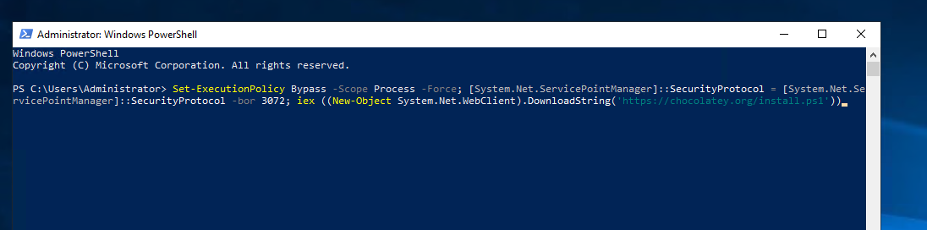

Step:3 Install JRE, JDK8, Maven, DOTNET SDK 5.0, git, IIS AND DOTNET WEB Hosting

# choco install javaruntime dotnet-5.0-sdk maven git jdk8 -y

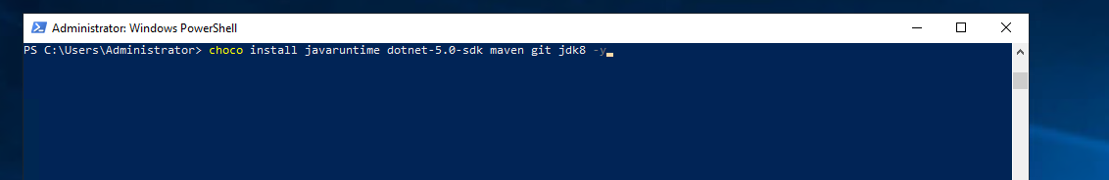

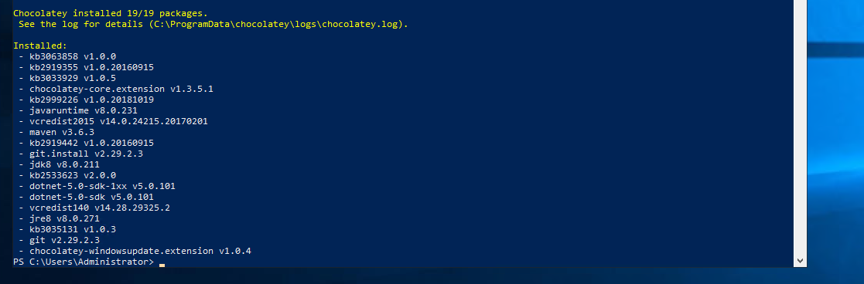

# Install-WindowsFeature -name Web-Server -IncludeManagementTools

# choco install dotnetcore-windowshosting -y

Step:4 Restart your server

# Shutdown /r

Step:5 Go To Start And Click On Server Manager

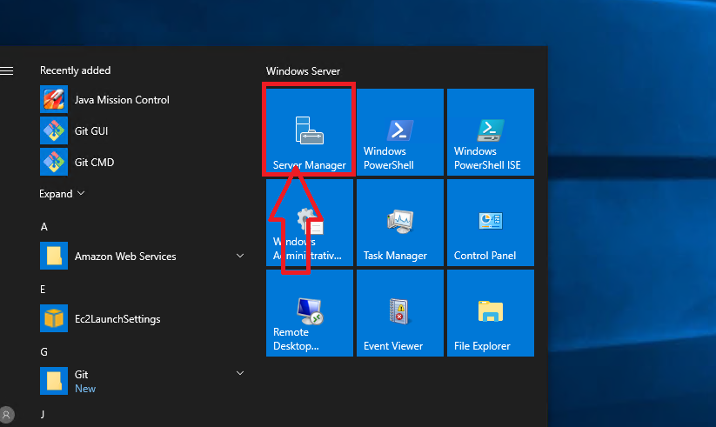

Step:6 Select Local Server

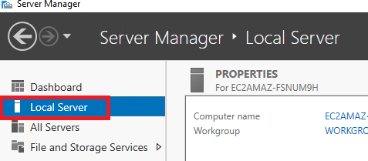

Step:7 Click On Windows Defender Firewall:Public On

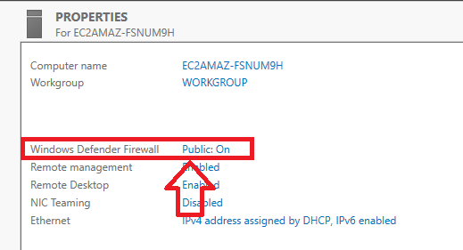

Step:8 Click On Public Network

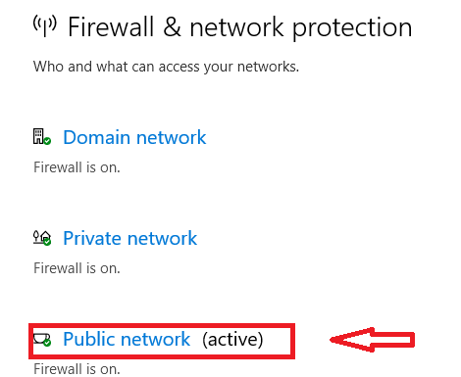

Step:9 Turn The Firewall Off

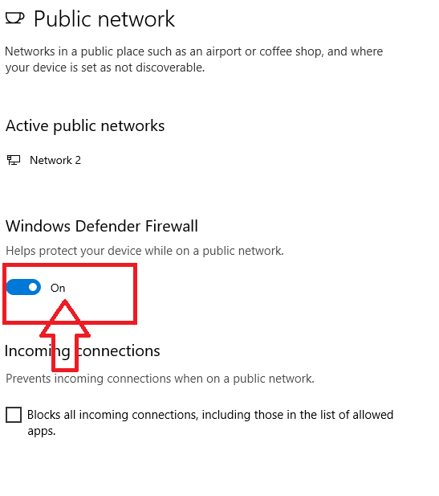

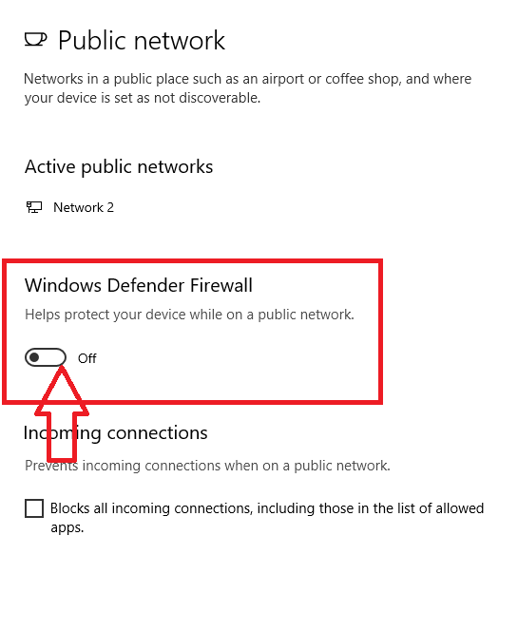

------------------------------------End Of Windows Node Pre-requisite---------------------------------------------